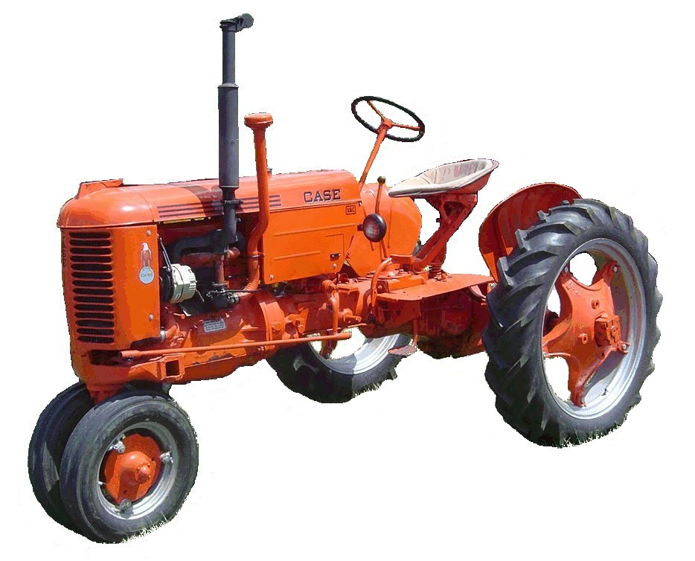
F O O T H I L L S

ANTIQUE POWER ASSOCIATION
ESTABLISHED 2003

Dear Members, October 2016
By the end of this month the bulk of the harvest will be in, the growing season will have ended, and the fall show season will be winding down. But it will also be a beginning: our newly elected slate of officers and board members will begin the work of the new year and some of us will start working on our winter projects.
But the end of this month will bring something else: our national and state elections will be only a few days away. Please make the necessary effort to cast your vote. It is your right; it is your privilege; it is the way our system works.

--- --- --- from the October meeting --- --- ---

- We continue to pray for those of our number, family, and friends who are in desperate need. We joy with those who have seen deliverance, and we stand with those who have yet to see it so they will be comforted, encouraged, and strengthened.

  - Shirley Robinson
  - Timmy Jones
  - Ray Weaver
  - Doug Huffman
  - Cole Abernathy
  - Ann Little
  - Kenneth Beach
  - Powell Sigmon
  - Vee Williams
  - Larry Sigmon

  - Donnie Elmore
  - Linda Sigmon
  - Lorna Sheets
  - Billie Sue Goforth
  - Steve Hefner
  - Wade Hefner
  - Norris Turner
  - Terry Martin
  - Eugene Hartley
  - Ira & Ann Cline
  - Howard Cooper
  - Kelly Blanton
  - Dot Hawn
  - Rev. Bobby Langston
  - Allen Everdyke
  - Don Johnson
  - Carl Porter
  - Jane Abernathy
  - Alice Newton
  - Ned Story
  - Frank Lippard’s wife
  - Charlie Crabtree

- Even though we had a smaller crowd than usual, the October meeting was quite a full meeting. We hope more of our members can make it next month for the fellowship we enjoy each month.

- The Swap Meet and Building Fund Raffle were a rousing success this year. Thanks to all who participated and helped (we’d miss someone if we tried to list them all).

- Also the club outing: a great time was had by all, although the crowd was a bit smaller than previous years.
  - Thank you, Glenn, for being the gracious host that you are.

- Amber Clawson, Director of the Catawba County Historical Association was our featured guest. She gave us some great information about CCHA: their purpose and goals, many of which parallel our own. There is hope for a much closer relationship with them in the near future.
  - She presented our club with a certificate of appreciation for all we have done in past years as a part of the Murray’s Mill Fall Festival.

- Elections were held for officers and Board of Directors. Most of the existing slate were nominated and re-elected, but there are a couple changes.

  - President: Kevin Black
  - Vice-pres.: Wilson Sigmon
  - Treasurer: Kermit Nash
  - Secretary: David Setzer

  - Show Committee chairman: Teddy Hefner
  - Asst. Show Chair.: Anthony Austin
  - Swap Meet Chairman: Butch McIntyre
  - Board of Directors: Phillip Spencer, Ned Story, Butch McIntyre, Tim Hollar, Howard Reinhardt, Teddy Hefner

- Speaking for all the officers and board members, we stand before you humbled that you would elect us to leadership roles in our club. We pledge to do our best for our organization so we can continue to be what we have been in our community and so we can continue doing what we can for our community.

- It is quickly coming up on the end of the year. That means membership dues are to be paid once again. As of January 1 all memberships are due.

  - Tim Hollar and Butch McIntyre are once-again overseeing the collection of dues. You can pay them at the monthly meetings, at Hollar Tractor, or Sig’s Tire, or you can send your $20 check to the club’s mailing address (below).

- The December meeting will be when we hold the drawings for equipment featured on the 2017 buttons, program, and tee-shirts. There are three requirements to be eligible for this drawing.

  - You must be present at the December meeting (or contact one of the officers to let them know you can’t make it, but you’d like to be included in the drawing).
  - If your equipment has not been featured in the last five years you will be eligible
  - If you have paid your 2017 dues, you are eligible

President: Kevin Black 828-464-1950 Vice Pres: Wilson Sigmon 828-256-2176
Treasurer: Kermit Nash 828-459-9616 Secretary: David Setzer 828-850-4943
Show Chair: Teddy Hefner 828-310-5525 Asst. Show Chair: Anthony Austin
Asst. Secretary: Kevin Sigmon 828-256-21

Board of Directors:
Phillip Spencer, Howard Reinhardt, Ned Story, Teddy Hefner, Tim Hollar, Butch McIntyre

Foothills Antique Power Association
5851 St. Peter’s Church Road, Conover, NC 28613
Foothillsantique.com
--- --- --- UP-COMING EVENTS --- --- ---

Oct 14-16 Charlotte Stumptown Tractor Show
Oct 20-22 Arden WNC Fall Harvest Days
Oct 22 Statesville Clark’s Chapel B. Ch. Car/truck show
Oct 29 Newton Spooktacular (need wagons)
Nov 3 Sig’s Monthly meeting
Nov 5 Mt.Grove Bap. Ch. Harvest Fest, 11AM- 4PM
Nov 4-6 Carthage 100+ Years of Progress show
Nov 12 Catawba Catawba Veteran’s Day & parade
Nov 12 Maiden Providence Rd Bap.Ch benefit BBQ
Nov 26 Maiden Maiden Christmas parade
Nov 28 Newton Lighting of the Square (need wagons)
Dec 1 Sig’s Monthly meeting + drawings for featured
eqpt
Dec 3 Taylorsville Taylorsville Christmas parade
Dec 3 Claremont Claremont Christmas parade
Dec 8 KeithSchronce’s Club Christmas gathering

☺ ☺ !!!!! HAPPY BIRTHDAY !!!!! ☺ ☺

October birthdays

1 – Doug Carrigan
1 – Brian McIntosh
5 – Tim Hollar
5 – Richard Hudson

7 – David Setzer

8 – Bob Huffman
13 – Jeff Bowman
17 – Todd Painter
18 – Johnny Parsons
19 – Eugene Lefeber
19 – Tyler lutz
28 – Keith Beck
28 – Richard Drum

November birthdays

3 – Jerry Matthews

3 – Marshall Wray
4 – Howard Williams
5 – Cody Hastings
5 – Barry Propst
6 – George Simmons
7 – Cory Keisler
10 – Jamie Allen

11 – Greg Williams
12 – Rusty Hastings
15 – Roy Lyons
16 – Frank Frazier
16 – Tony Huffman
18 – Norris Turner
19 – Bruce Roseman
20 – Brandon Bowman
21 – Michael Harrill
21 – Zach House
22 – Bradley Fulbright
24 – Forster Edgar
26 – Kevin Black
27 – Henry Wagner
27 – Toby Aiken
28 – Donald Bowman
29 – Dennis Lutz

-- --- --- THE CLASSIFIEDS --- --- ---

Is there anything you would like to sell or are you looking for something special? List it here.
(Item listings will run for 3 months before expiring. Let us know when an item is sold or bought.)

FOR SALE WANTED

Farmall Super A, taking offers, Wilfred Parker, Old-style, 3-wheel hay rake,
(828) 428-9193 (16-06). Kermit Nash 828-312-2071 (16-07).

Allis-Chalmers B engine,
Troy Elmore (16-10)

--- --- --- a thought for the month --- --- ---

In these newsletters I try to avoid speaking of the issues of the day. We get far too much of that pressed upon us from the news media and from those around us. Instead, I try to focus on the truths of what God has given us through Christ – something we will not hear from the world, yet something we need to be reminded of often because the world will choke it out of us if we give it half a chance. But with all the unrest in recent months, all the insanity in our country and our world, and with the elections coming up, something needs to be said.
Speaking of and hearing about the benefits and joys of the gospel of Christ is a wonderful and needful thing, but if it is not brought into the reality of the world in which we live, it is little more than religious rhetoric or emotionally-charged, feel-good philosophy and neither is of any true help in living life in this world. We live in a world that is becoming more and more hostile and actively opposed to anything having to do with The True God. Either we conform to it, or we become transformed into lights in this dark world. The former is easy – we need do nothing, but the consequences are eternally dire. The latter is challenging, but God has given us all we need (2 Ptr 1:3-4).
Behind all the killings, all the mud-slinging, all the unrest, and all the asking “why did this happen?” is one thing: unrighteousness – enmity against God (Rom. 8:7-8) – sin and death. This is the reality of the world in which we live. Yet, through Christ we are to stand apart from the world (even though we are in it). In Christ God has made us to be righteous, for He has placed Christ within each of us as our righteousness (Col. 1:27); 1Cor. 1:30). In him we can live in righteousness even if those in the world around us are active and defiant in their unrighteousness.
Righteousness and unrighteousness are like oil and water, or light and dark – the do not mix, they cannot peaceably coexist (2 Cor. 6:14) and the unrighteous will always be the aggressor.
Through Christ, God has given us His spirit to be in us as the ever-present presence of Christ himself, our source of comfort and strength in any situation we may find ourselves (2 Cor. 1:1ff) enabling us to comfort, encourage, and strengthen others also. But to be comforted and strengthened and to be able to comfort others, we must listen to the Spirit, heed his guidance, and walk with our Lord (not just in his steps) regardless of the circumstances. We can either conform ourselves to this world or be transformed into living displays of Christ’s righteousness.
It may be that we have a situation with a co-worker or a family member that has stymied us as to what to do. Seek our Lord’s guidance. He will provide, but are we listening? It may be the upcoming election – who should I vote for. Seek our Lord’s guidance. He will guide, but will we seek his help?
Most people do not seek help from our Lord and they end up living with the consequences of their decisions and actions, consequences that very often adversely affect someone else.
Is not our Lord able to guide both you and me into that which is best for both of us not only individually, but collectively? Certainly he can! Is he not willing? He certainly is! The only question, then, needful for you and I to ask is: am I willing to listen?
God bless you all.
See you in November.
Your Secretary, David Setzer

